ADO 13397: 'Lawyers/Law Firms' child question remain on display after refilter Industry type to another industry type other than 'Professional, Scientific, and Technical Services.

Steps to replicate:

1.      Create a quote and set the:

* + Industry Type: Professional, Scientific, and Technical Services
  + Industry Class: Lawyers/Law Firms

Note: The child question '**Does the company derive more than 10% of its business from collections?'** appears

2.      Changed the Industry type to another type other than Professional, Scientific, and Technical Services

Actual result:

The industry class becomes blank, but the 'Lawyers/Law Firms' child question remains on display

Expected result:

Child questions should not display when Industry Class is not to 'Lawyers/Law Firms'

Screenshots:

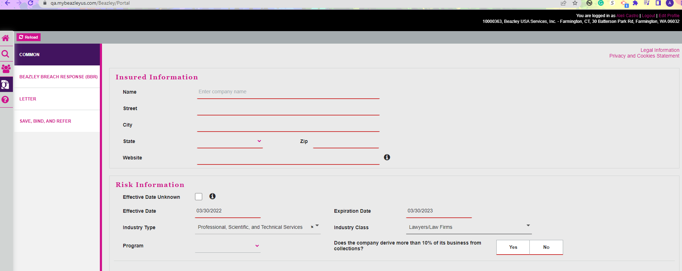

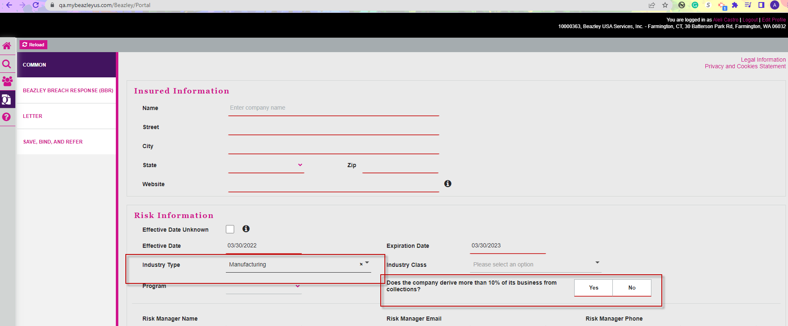

**Re-Testing:**

Create a Quote selecting

Industry type: Professional, Scientific and Technical Services

Industry class: Lawyers/ Low Firms

The message “Dos the company derive more than 10% of its business from collections” appears.

When changed the Industry Type to Public Administration, the Industry Class went unselected and the message disappeared as expected.

